Storyboard for GoWeather Tablet Format

Lewis from Chelsea awakens to the day of one of the biggest world cup games this month. To be prepared for the day, Lewis reaches for the tablet and opens the GoWeather! App.

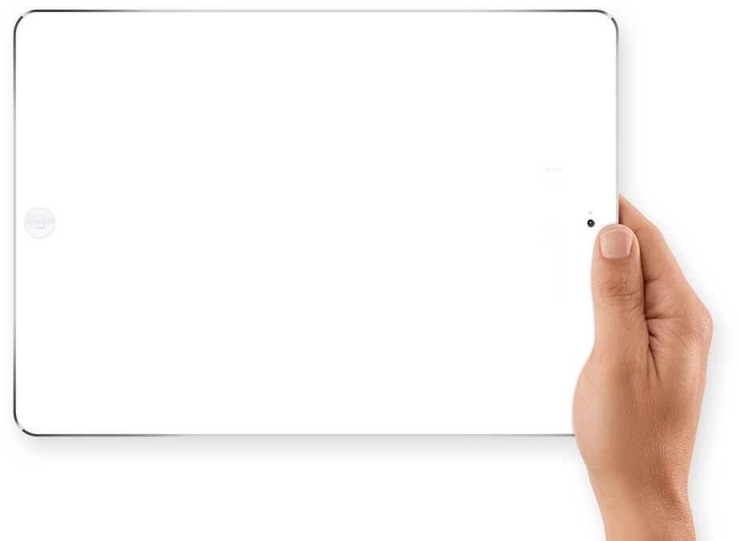

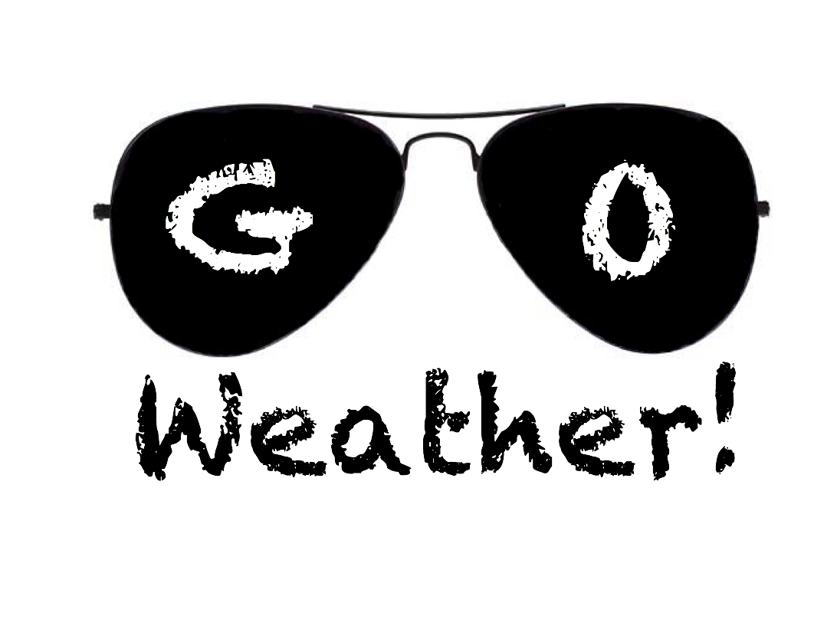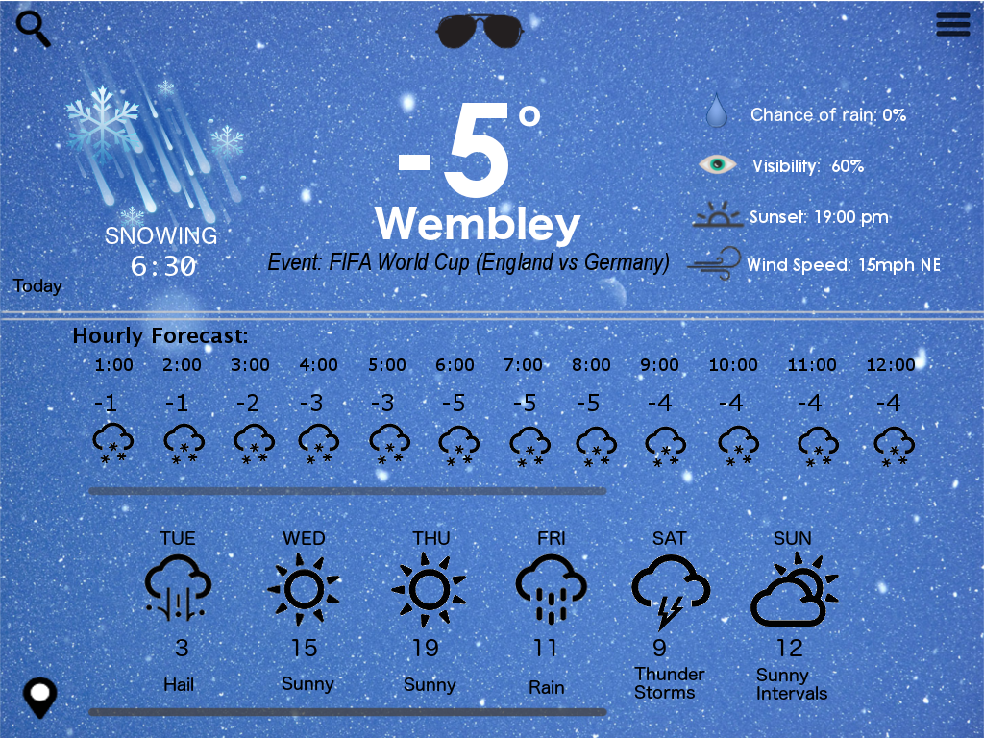

So he searches for the event location in Wembley and locates the event type.





**Wembley Stadium**





**Wembley Park**



**Wembley Arena**

**Wembley Park**

As it is a few hours away, Lewis scrolls to left on the hourly forecast, to find out the temperature for the game at 5:30pm tonight.



Lewis wants this day to run smoothly and searches for any uneventful weather warnings. Phew, the coast is clear with weather issues.







*Share* *Weather*

*Saved Events*

*Weather Warnings*

*Edit Home Location*

*Information*









Weather Warnings:

Tomorrow: Icy Patches.

So excited for the game, the big fan of England shares the weather with his companions that he will be meeting up at the game.



*Share* *Weather*

*Saved Events*

*Weather Warnings*

*Edit Home Location*

*Information*











Share:

Looking to stay nearby the stadium, Lewis looks out for the weather for the next few days, to book tickets for more games to come!

